**Spring 2024 CS5720**

**Neural Networks & Deep Learning - ICP-3**

Name: Sravya Reddy Pilli

Student Id: 700747154

Github link : <https://github.com/09sravyareddy/NNDL-ICP3>

Recording Link: <https://drive.google.com/file/d/1gNppHpu9QoXxUN3BtKQBlsY46_aP06hs/view?usp=drive_link>

**Code & Output:**

1) Create a class Employee and then do the following • Create a data member to count the number of Employees • Create a constructor to initialize name, family, salary, department • Create a function to average salary • Create a Fulltime Employee class and it should inherit the properties of Employee class • Create the instances of Fulltime Employee class and Employee class and call their member functions.

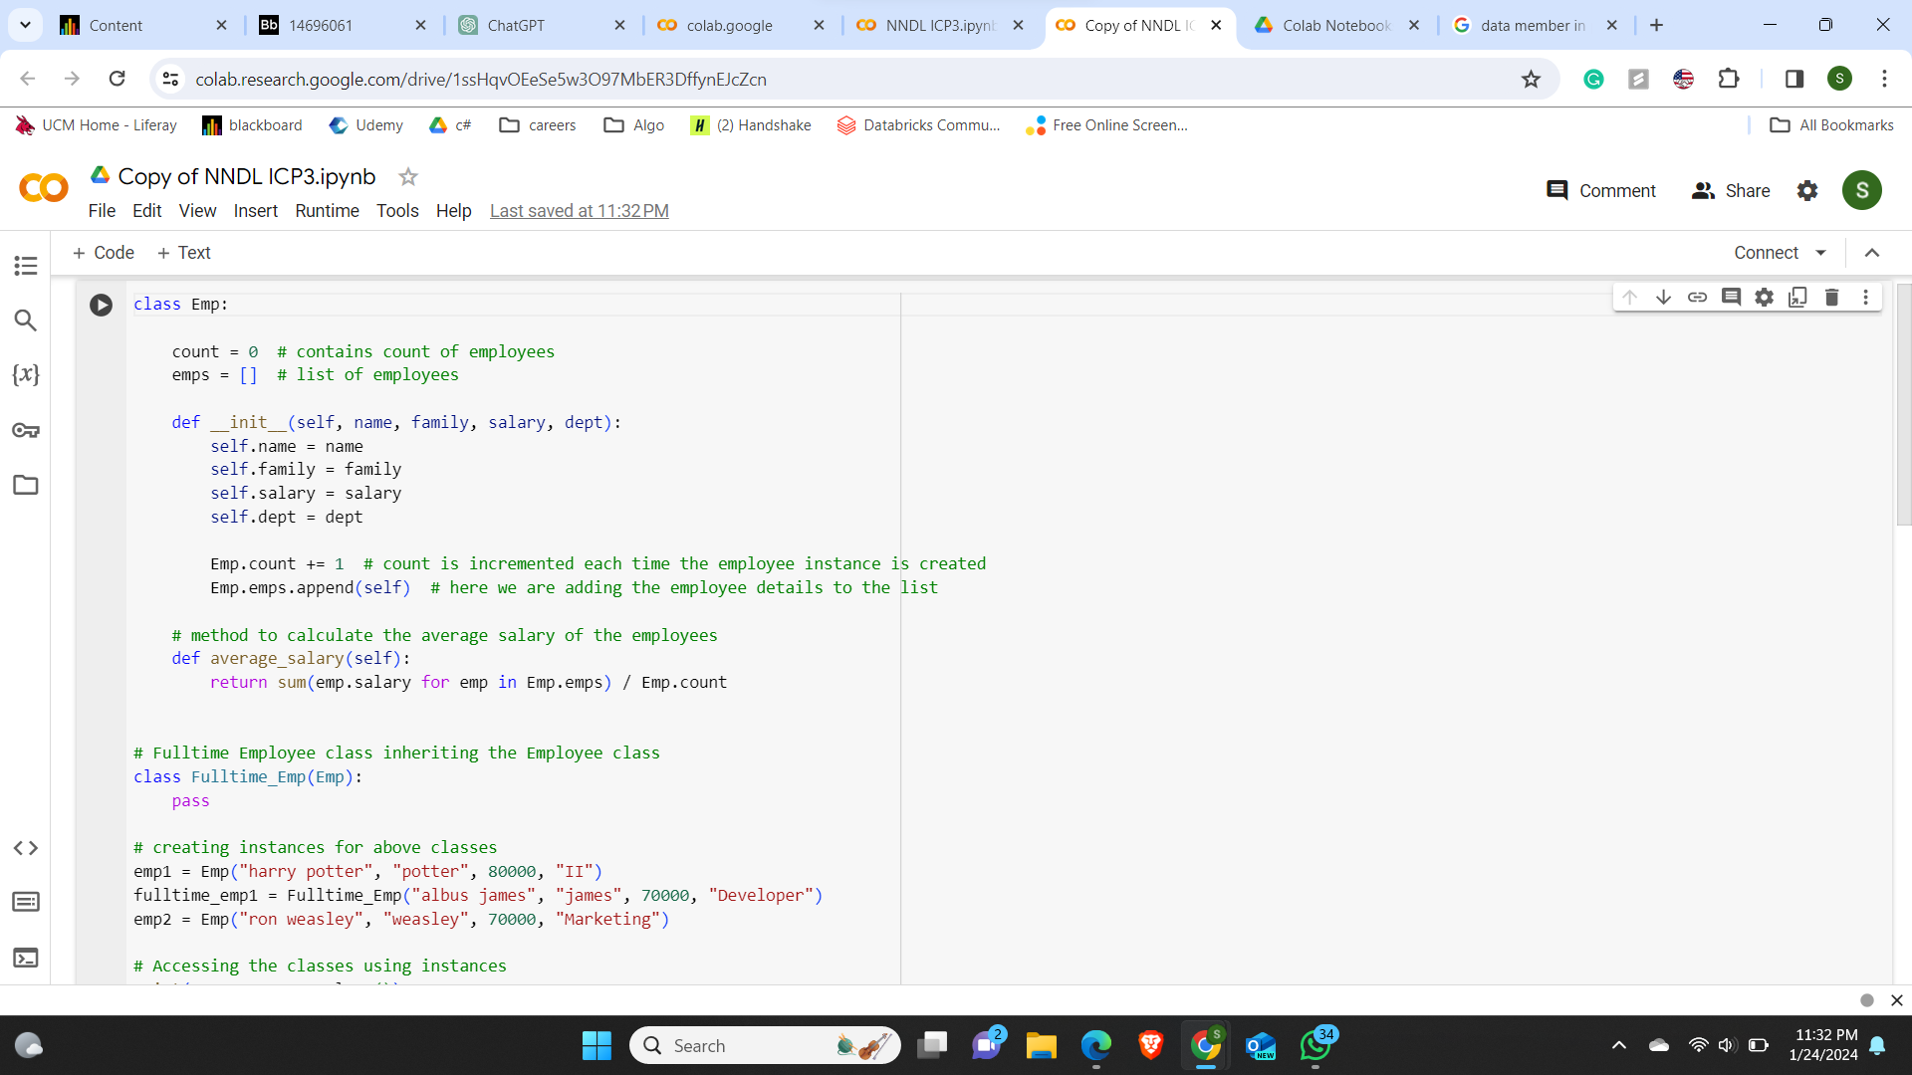

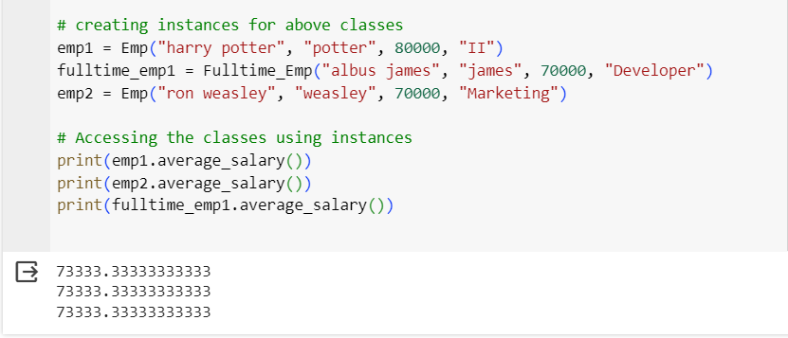

2) Numpy Using NumPy create random vector of size 20 having only float in the range 1-20. Then reshape the array to 4 by 5 Then replace the max in each row by 0 (axis=1) (you can NOT implement it via for loop)

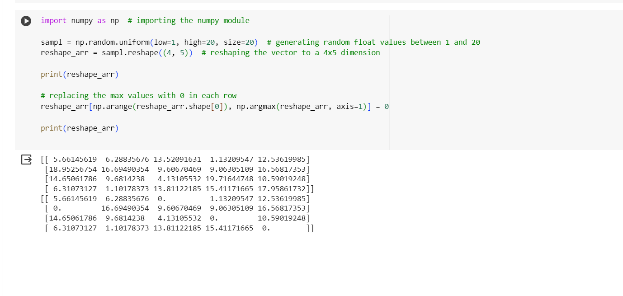

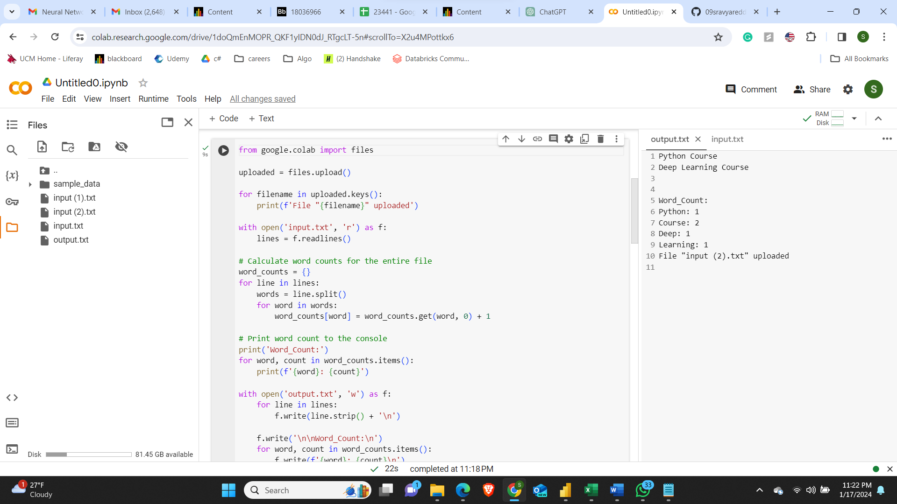

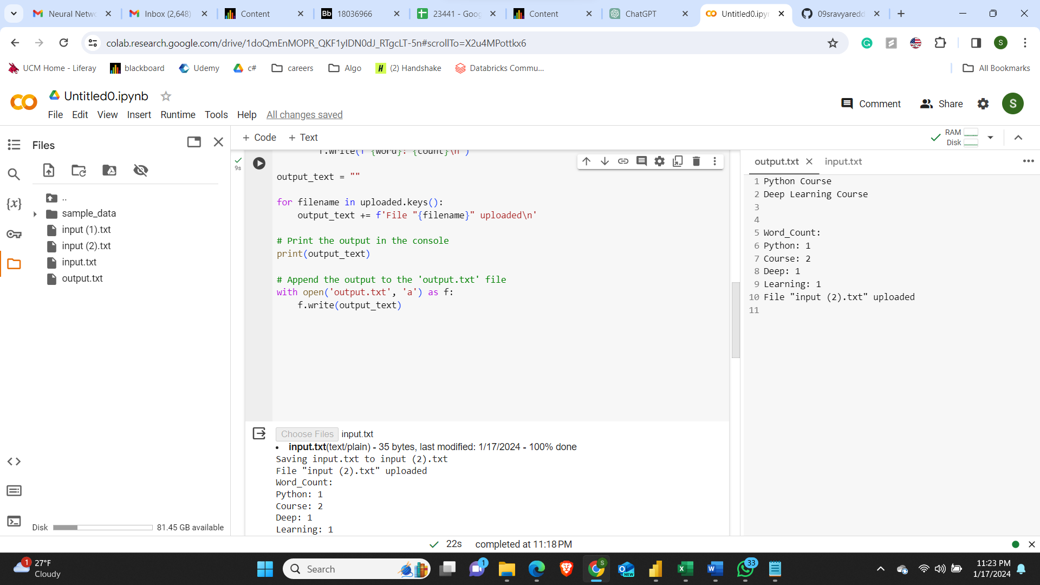

output.txt File:

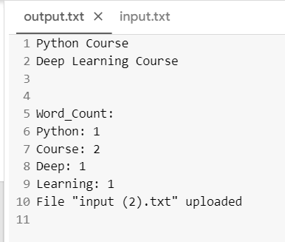

3)

